Basic instructions for Matrix inversion code by Gaetano Magnotti

Versions

* Gatano Magnotti
* Jun 2016: Comments by Silvan Schneider
* Sep 2016: Comments by D. Geyer

# Basic instructions for Matrix inversion code

Steps:

1. Start Matlab
2. Set the paths in Matlab

In Home/Set Path add the path to software for Dirk with all subfolders.

Other ways to do it: -

In command window: “addpath(genpath('C:\D\Raman\MI_Mtlb\2016\')) ”

or add them to the pathdef.m file

1. Open Raman GUI

* In Matlab Command Window type “guide”
* browse to the “your_path/GUI” folder and select Raman_GUI.

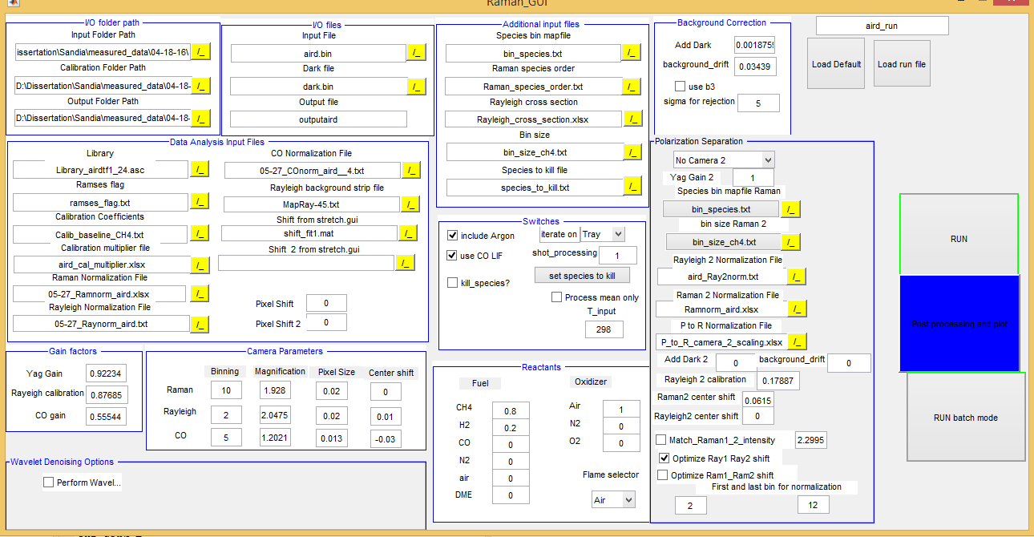

Figure Screenshot of Raman GUI

Comment: Start from data in “data for testing” to familiarize with the code.

Getting the GUI started

* Press the green arrow to start the GUI (or tools/Run if no green arrow is present)
* Press the “load Run file “ button and select the run file “run.txt” in “Software for Dirk/data for testing/Calibration” (DG: currently in “C:\D\Raman\MI_Mtlb\2013\Examples\Calibration\...)

I/O folder path

Change the parameters in I/O folder path section by clicking the ./ yellow button:

* Set “input folder path” to “your_path/data_for_testing”
* Set “Calibration folder path” to “your_path/data_for_testing/Calibration”
* Set “Output folder path” to “your_path/data_for_testing/Output”

This parameter can also be changed in the run.txt file before using a text editor.

I/O files

* Select the input .bin file (for example aird.bin)
* Select the corresponding dark file (for example dark.bin)
* Type the desired output file name (if you don`t like the default one)

Additional input files

This section points to some input files that are required but that you`ll probably never change for a given dataset.

* Bin_species.txt contains in the first column the species of interest, the other columns the camera bin (or bins) associated to it.   
  For example CO2 2 3 -1 means that bin 2 and 3 of the camera will be associated to CO2. The -1 is used to assign 3 columns to all species independently of the number of bins actually used.
* Raman_species_order indicates the order in which the different species are stored in the matrix. No need to modify it unless you`re adding more species.
* Rayleig_cross_section.txt contains the Rayleigh cross section and the molecular weight of all species. It also contains C2 and B3 (terms that appear in the matrix inversion but that do not contribute to the mass or mole fraction) but the values are set to 0.
* Bin_size_ch4.txt contains the number of pixel in each bin. It depends on the binning applied on the camera, so it is generally the same for an entire dataset.
* Species_to_kill.txt is a text file containing a list of species to suppress during the calculation. It affects the results only if the switch “kill species?” is active.

Background correction

This section includes parameters to improve the background correction.

* Background drift is a uniform shift of the background (binned) level.
* AddDark is a shift to the dark that is proportional to the energy of the Yag laser (on a single shot-basis) and to the size of the bin.

The 2 parameters are determined from air files. Background drift changes during a day, AddDark is considered a constant throughout the day.

* Useb3 is a switch. When selected it forces the mean value (over the total number of shots) of the b3 channel to be 0.
* Sigma for rejection is used for a rejection criterion of bad shots based on the background channel and the Yag laser energy. Shots for which the B3 channel or the Yag laser energy differ from their mean by more than number of “sigma_for_rejection” standard deviations they are considered bad shots and removed.

Data analysis input files

* Library: select the appropriate library file (see instructions in the Calibration section on how to generate it). Typically choose the library file generated based on (DG: account for change in the apparatus profile) an air file close in time to the data you`re analyzing.
* Ramses flag: file indicating which species and crosstalk are used from the Ramses library. The first 2 column identify the species-crosstalk term (same order as in the Raman species order file), the last column is set to 1 if the Ramses library is used, to 0 if the old Sandia polynom is used.
* Calibration coefficients is the file containing the Raman cross section for all species and crosstalks. It also contains the temperature dependence, but they are not used for species or crosstalk for which the ramses flag is set to 1. This set is typically left unaltered.
* Calibration multiplier is an excel file containing for each species and crosstalk a scalar that multiplies the cross section reported in the calibration coefficient. This file is obtained from the calibration routine described later on in this document. Typically you`ll use a few of these files to analyze a data set collected during a day
* Raman normalization file is a .xlsx file containing normalization curves for all the Raman species. During the calibration process you`ll generate as many of these curves as air data sets collected. Order is:

|  |  |  |  |  |  |  |  |  |
| --- | --- | --- | --- | --- | --- | --- | --- | --- |
| A | B | C | D | E | F | G | H | I |
| CO2 | O2 | CO | N2 | CH4 | H2O | H2 | C2 | B3 |

* Rayleigh normalization file, same as above but for the Rayleigh signal and .txt. file.
* CO normalization curve, same as above but for the CO LIF. Typically only one from data taken at the beginning of the day is available.

Rayleigh background strip file indicates which strips are used for further background subtraction in the Rayleigh data processing. Do not change it for Sandia data, but you may need to adapt it to you setup for your data. Has same number of strips as Ray image (perpendicular to beam)

Shift form stretch gui: gives data for widening up the beam generated by stretch_GUI in Calibration step from comparing spectrally resolved N2 and O2 spectra

Pixel shift: add the shift between the experimental spectrum and the spectrum generated by Ramses. You`ll need a full resolution N2 spectrum to determine it. As an alternative you can play around with this parameter to reduce errors in the bowing correction (not recommended, but sometimes necessary)

Switches

Include argon: add argon to the results as a fraction of the N2 content based on standard air composition. Deselect if air is not the only source of N2.

Use CO LIF: if selected the algorithm uses CO LIF measurements to compute mole, mass fractions etc.., otherwise it will use the Raman CO.

Kill species: select to kill some species. A pop up windows appear allowing you to select species to kill. It then writes the species to the species_to_kill.txt file. Performed by multiplying it with a small factor

Iterate on: allow choosing between T Rayleigh, T perfect gas and thermocouple temperature. In the last case it does not iterate, but fix the temperature. (this last option is used during the calibration process for air, or pure gases).

Missing:

Iterate on T_input, Process mean only,

Not there any more? Shotprocessing: set to 1 to analyze every shot, 2 will analyze every 2 shots and so on. Useful to take a quick look at large data sets (I put it there a long time ago, but maybe I never tested it).

Gain factors

Yag gain: determined from the calibration routine to match the perfect gas temperature to thermocouple temperature in air

Rayleigh Calibration: determined from the calibration routine to match the Rayleigh temperature to thermocouple temperature in air

CO gain: determined from the calibration routine to match the CO LIF measurements to the predicted values in a premixed rich flame (ch4-8.bin typically)

Camera parameters

Parameters for the 3 cameras. Modify it if you are processing data not from Sandia. The last column, center shift is used to correct for relative shift of the 2 cameras (in vflame look at Tray/Tpg and the CO and CO-LIF peak locations)

* Binning: refers to binning along probe volume

Reactants

This section is used as in input in calculating the mixture fraction. Select the relative concentration of the species in the oxidizer and fuel streams.

Flame selector: Set to CH4. (it comes from a version of the code before my time, and was used in the plotting routine. I changed many things and it is destined to obsolescence, but there might be few places where I need to remove it)

Update

Press the update button to save the changes

# Basic instructions for CALIBRATION (Step 1)

Calibration GUI

The Calibration GUI generates all the files needed in the main MI inversion code.

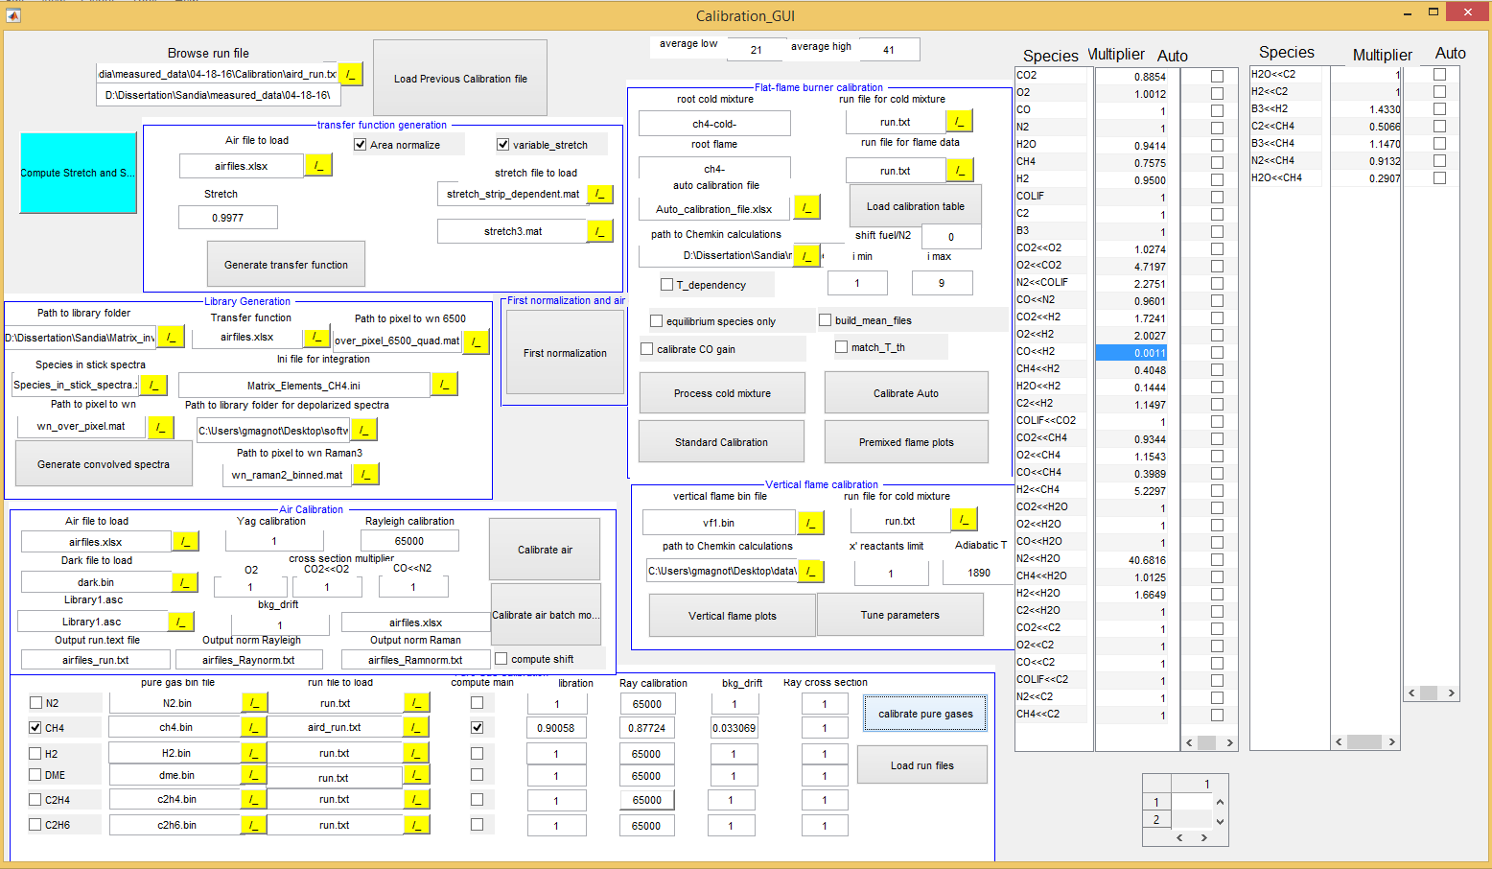

Figure : Screenshot of Caibration GUI

Start of Calibration GUI:

* type “guide” in the Matlab command window,
* then browse and select “your_path /GUI/Calibration_GUI.fig”.
* Press the green arrow to start the GUI.

In the previous step you opened the Raman GUI, loaded a run file and changed the I/O path, correct? If not do it now.

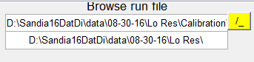

Figure : Screenshot of place to set the run-file

* With the correct I/O path, load the run.txt file in the calibration folder (“your data path/Calibration”). First select the appropriate run file by pressing the yellow “./” symbol and then press “Load run file”.

DG example: “D:\Sandia16DatDi\data\08-30-16\Lo Res\Calibration\run.txt”

It will fill the 2 large arrays on the right side with the content of the calibration multiplier file indicated in the run file.

**Important!!!** To change the input for this subroutine you need to reload the file to have an effect.

1. Library generation

Library generation consists of two steps.

1. Generate the transfer (apparatus) function
2. Convolute the Ramses stick spectra with the transfer function

These two steps are described in the following

1. Transfer function generation

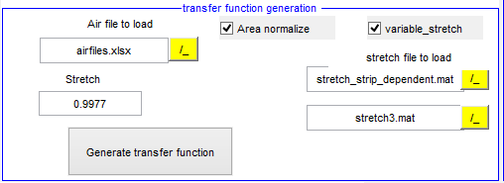

Figure : Input Window for Transfer Function

This section generates the transfer function (apparatus function) out of the Rayleigh profile of the airfiles. This is required for the convolution of the stick spectra. It assumes, that the apparatus function on Raman and Rayleigh is essentially the same but has to be scaled to account for the difference in optical magnification. (Correct to a certain degree)

* Set path to library folder containing the output from Ramses (stick spectra): “…/subroutines/Library_spectra“

DG example: D:\Sandia16DatDi\Matrix inversion code\Library_spectra

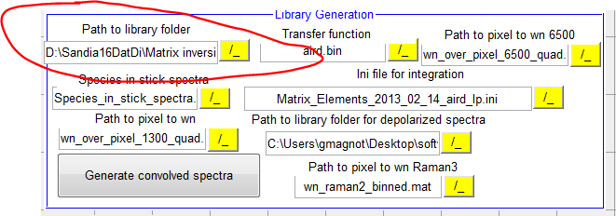

* Define air files where transfer function is created from: open “Airflies.xlsx” in the calibration folder. This file is continuously filled (name of resulting transfer function files: XXX_tf.spe files) during the computation of the transfer function.
  + Input in Airfiles.xls: 1. Col – air files for profile, 2. Col – corresponding dark file
  + Output in Airfiles.xls: 3. Column: Transfer function file generated , 5. Col (for high-res ?)
  + DG example: D:\Sandia16DatDi\data\08-30-16\Lo Res\Calibration\airfiles_D1.xlsx
* Stretch factor to apply to transfer function:
  + Possibility 1: give a constant stretch factor to broaden spectra (turn off variable stretch)
  + Possibility 2: check variable stretch : a stretch dependent on the strip position is loaded.
    - Stretch file to load: 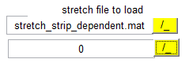
* Create the stretch file for possibility 2

This GUI creates a strip dependent stretch factor, correcting for difference in transfer function and spectrally resolved N2 spectrum by (1) matching the peak values of the n2 spectrum. The optical magnification between Raman and Rayleigh is not constant in strip direction due to optical aberrations. Thus, this possibility is the better one.

* + Hit the following button to start the stretch GUI: [Compute Stretch and Shift]  
    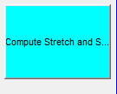
  + The following GUI appears (new version of the stretch_factor GUI)

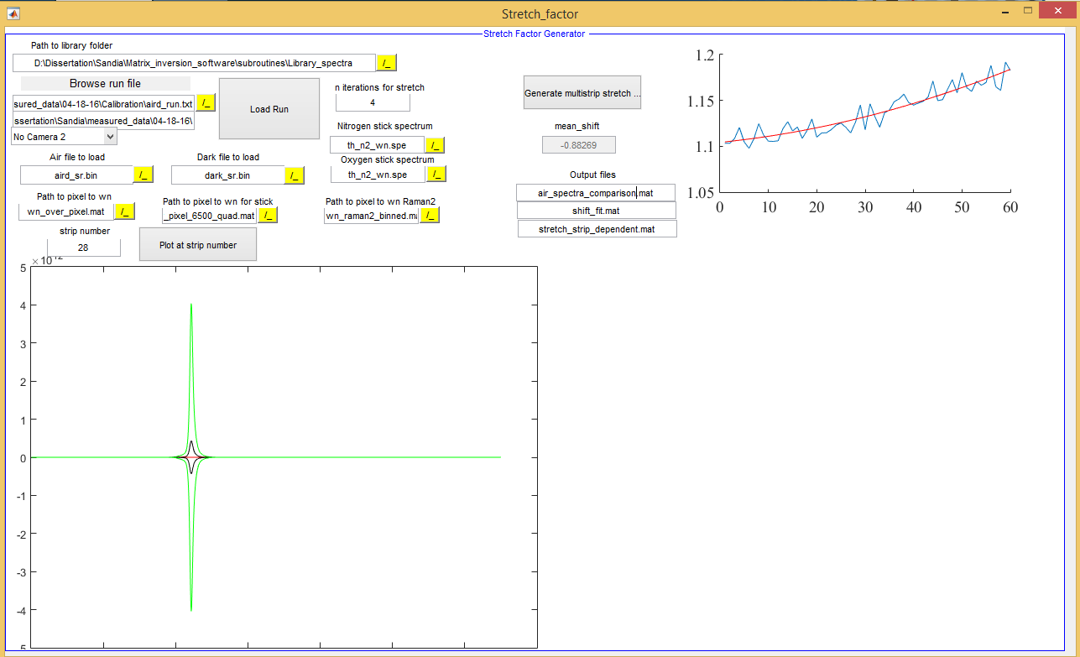

Input for stretch file computation

* + Load the run file (for air) from the library folder – (for instance aird_run.txt): 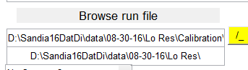

DG example: D:\Sandia16DatDi\data\08-30-16\Lo Res\Calibration\aird_run_D1.txt

Question: Where do we need the run file for ? To set the paths ? The other files are defined in the Input below

* + Set the filename for the spectrally resolved air file (N2 is required in the measurement– mostly named XXX_sr.bin)
  + Set the filename for the spectrally resolved dark file (dark_XXX_sr.bin)
  + Make sure that the wn_over_pixel file is provided (1300) in “Path to pixel wn” (for instance in “D:\Sandia16DatDi\Matrix inversion code\Ramses input files\wn_over_pixel_1300_quad.mat – gives wavenumber over pixel info. In principle also the result from CalcDispersion (pp-spline fit, even a little more nice) could be used for that purpose.
  + Nitrogen stick Spectrum from Ramses is required as input (th_n2_wn.spe)
  + Oxygen stick Spectrum from Ramses is required as input (th_o2_wn.spe)
  + Dark file to load: can be empty since stated in airfiles.xlsx.   
    Question: Is the dark file used at all ? Or is it only relevant for the paths etc.

Running stretch file computation

* + Hit the [Generate multistrip stretch parameter] button  
     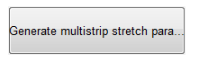
  + Show the results of the computation: Set the strip number and hit the following button  
     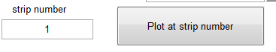

Output of stretch file computation

* + Output files are written to the calibration pat. DG example:   
    D:\Sandia16DatDi\data\08-30-16\Lo Res\Calibration\air_spectra_comparison.mat
  + air_spectra_comparison.mat : ?? Question: What is the content of the file ?e
  + shift_fit.mat: ?? Question: What is the content of the file ? Pixel shift for each strip ? Is the strip dependent pixel shift used at all ?
  + stretch_strip_dependent.mat: Stretch factor for each of the strips.   
    Result of the fit (filter procedure)) in strip direction. To be applied to the Rayleigh images taken in air the various aird_xx.bin files over day. Thus the transfer (apparatus) function is defined frequently for each day and different libraries are generated.
  + Mean shift: mean shift to be applied to Ramses library 🡺 pass as shift factor ??? Question: where exactly to be passed
  + Mean shift_2: mean shift to be applied to Ramses library for 2. Setup (high-res, depol) 🡺 pass as shift factor ??? Question: where exactly to be passed

Back to main window of transfer function generation -> Figure 4

This section generates the transfer function by using the:

1. Rayleigh images from each aird_XX.bin file 🡪 defined in airfiles.xlsx (DG: airfiles_D1.xlsx)
2. The stretch_strip_dependent.mat generated in the previous step. Should be in the calibration folder.

* Area normalization: default checked: normalize area of Ray image to 1.0 -> required (otherwise the calibration factors would change for each library !!)
* Stretch2: stretch for polarization separation side



See Figure 4, identical.

Output of transfer function generation

* Output: .spe files (does not look like the Winspec spe files): the files generated are listed in the third column of “airfiles.xlsx” (respective airfiles_D1.xlsx). Fifth column: for the second setup ?
* Naming convention: transfer function from air__1.bin 🡪 aird__1tf.spe.

1. Library Generation

The Library_spectra/stick_spectra folder contains stick spectra (DG: not totally correct…) generated from Ramses for all the species of interest. I no longer use the convolution included in Ramses. There are a couple of reasons for that:

1. The Ramses stick spectrum does not depend on the specific of the set-up, so it needs to be generated only once. The convolution itself can be performed without computing the individual transitions again and again. (DG: good point)
2. DG: This could be improved by not using the pixel results but the individual transitions instead. Ramses generates these individual transitions for most molecules. Nothing to be done immediately, but it should be on the list

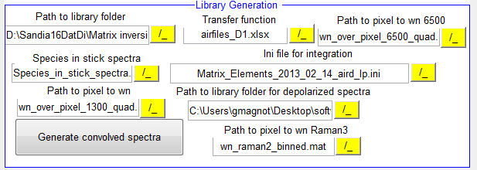

This section generates the libraries using the transfer function generated by using the transfer function generated from the different aird__XX.bin (airfiles) listed in the Excel file airfiles.xlsx (DG version: airfiles_D1.xlsx).

In a second step the libraries are integrated over the pixel range defined for the individual species.

Input

* Path to library folder: select folder that contains library files
* Path to Pixel to wn: Pixel to wavenumber file - choose: wn_over_pixel_1300_quad.mat. This file assigns the wavenumbers to the individual pixel in spectral direction.   
  DG comment: Ramses should already provide this information. Might be necessary for the experimental stick spectra. Could also be checked against the results from calc_dispersion, maybe the pp_spline fit in cacl_dispersion is slightly better 🡪 Nicola ?
* File list containing transfer functions determined from Rayleigh images in air: airfiles.xlsx (sheet 1, column C)
* Ini file for pixel range definition for integration of the spectra to generate the response curves:   
  “Matrix_Elements.ini “ (low res) or “Matrix_Elements_hr.ini “ (high res) pixel ranges for the channels are stored in this file (file is in calibration folder). Essentially the ini file of the DA integration code from 2007.
  + [I/O Paths]: order of Raman channels
  + [Strips]: change for high res! What about optical axis. Is it used ??
  + [Pixel shift]: number of pixel shift in spectral direction. Affects the size of response fct file
  + [plot]
  + [species]: what species X talks to compute
  + [species pix]: define binning regions
  + [LIB files] : convolved spectra generated by the current transfer function; being overwritten in …/subroutines/Library_spectra/conv_spectra
  + [CALFILE]: reference data of old Sandia polynomials
* Species in stick spectra: choose: Species_in_stick_spectra.xlsx; not used – keep like this. Option for experimentally determined spectra ??

Running computation of response functions

* Hit [Generate convolved spectra]  
  
* Convolution of stick spectra with transfer function are performed
* aird__1tf.Library_aird__1tf.asc: Name generated from Library_ and the transfer function name (aird__1tf.bin) as listed in the Excel airfiles table

DG: I. script Calibration_GUI, fct “generate_convolved_spectra_Callback”, line 1662: movefile results in a crash. Maybe the files to be moved were not correctly closed. Changed to copyfile to circumvent that. Has to be improved.

First normalization

Hit [First normalization]

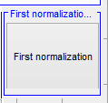

The GUI First_normalization will pop up: it generates throughput normalization to flatten the profiles of the species. The normalization curve is generated such, that the Raman-signal is strip-wise corrected to the throughput ratio of strip_no_i /strip_no_central. Using that approach only one calibration coefficient can be used for all strips (for a single species).

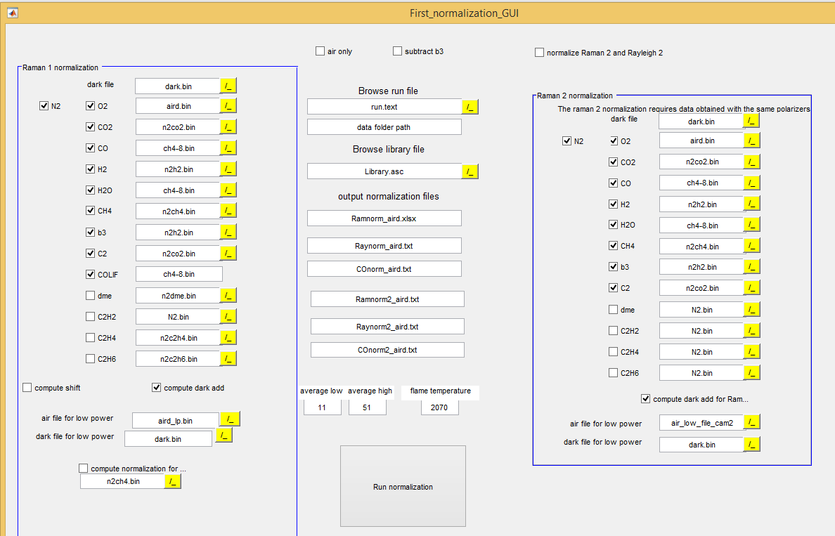

Figure : Screenshot of first normalization GUI

**Raman1 normalization:**

* Select files which are used for normalization (first few are shown here)  
  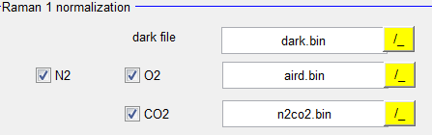
* Compute dark add (default checked): does the dark correction composite of:
  + Dark drift
  + Dark add determined from aird and aird_lp image (giving a YAG energy proportional correction term (signal in CH4 channel) determined from a ratio of the two signals at different laser energies.
* Browse run file: air run file closest in time to the calibration measurements: “aird1_run.txt”  
  Load run file – output folder path is also selected then
* Browse library file: Select file which belongs to the air run file. For example “Library_airdtf1_24.asc” – use just one library holding all species response functions. This name is also listed in the Excel file “airfiles.xlsx” (airfiles_D1.xlsx) – see Sheet1 - that holds all the information of the air calibration.
* Output normalization files: state here which files are filled with found normalization
* Average low/high: state which strip range (around optical axis) to get YAG gain, etc – can be commented out because performed in next step (Is it that way ??)
* Flame temperature: Temp for the flat flame calibration file (for corresponding mixture). Temp is given as input in normalization procedure, Rayleigh is not used here.  
  Comment (from Silvan ? – to check) not used any more. Temp for ch4-8.bin to tweak bowing vs. throughput normalization (DG: I would not know to distinguish between bowing and throughput normalization in the data – is not the same in some respect ??)

Settings not used as often

* Computes shift (default unchecked): determines the shift of the spectra by assuming the crosstalk factor of CO2<<O2 in air being = 1 (i.e. the same for all strips) ( if not there must be a shift in the library spectra!),  
  slows down code if checked, not well established.   
  Discussion with Gaetano: Take a spectrally resolved air shot together with the binned frequent aird_xx.bin shots and determine the shift factor from that several times during the say. Use this shift factor as input in the Raman_GUI. This shift factor could be also implemented in the aird_run file.
* Air only: unchecked: doesn’t use other species
* Subtract b3: unchecked; if checked it subtracts the signal on the b3 channel to get 0
* Question: Compute normalization for integ… - what is it for ??

Running computation of “First_normalization_GUI”

* Hit [Run normalization]  
  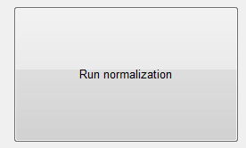
* figure comparing old and newly found normalization factors will pop up after the computation

Output: “First_normalization_GUI”

* Output normalization files
  + Ramnorm_aird.xlsx
  + Raynorm_aird.txt
  + COnorm_aird.txt

Air calibration

This section generates the calibration factors for N2, O2 and some x-talk factors by comparing measured files to known concentrations (temperatures are slow known. Conditions are known since these are the calibration flows

Input: airfiles.xlsx –sheet 1

Screenshot Version Sept 2016 – uses the filenames and the other info (dark file, library info etc.) from sheet 1 (filled in previous steps) of the airfiles.xlsx in the calibration folder (DG airfiles_D1.xlsx) to compute the air calibration settings. .

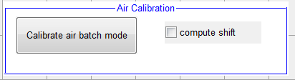

Shift factor: tries to generate the same calibration factor for each of the strips from CO2 << O2 ??

Screenshot of older version ?

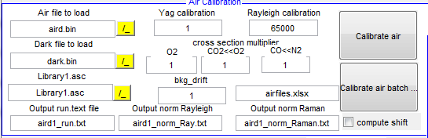

Hit [Calibrate air batch]:

Output: given in airfiles.xlsx –sheet 2

* + Name of air file, YAG_gain, Rayleigh, bkg_drift
  + Calibration factors O2, CO2<<O2, CO<<N2 and name of output calib file

Plots results: profiles should be flat and at the correct concentration (mole fraction)

Pure Gas Calibration

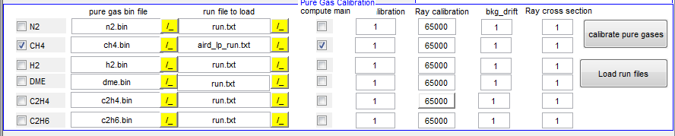

How it works:

1. Kills all species except the one you want to calibrate (done in the code itself)
2. Adjusts Raman response factor so that T_pg matches T_thermocouple
3. Adjusts X-Talk factors for this species

Perform only for ch4 and h2 (n2 is done in previous step with air) consecutively

* For ch4 – laser on low power : aird_lp_run.txt (air reference file is also on low power)
* For H2 - Load airdXX_run.txt which is closest in time to the
* check compute main: create new response factor (actual calibration), if unchecked it takes the original value of response talk factor in run_file.txt (necessary if e.g. thermocouple was not in place)

Hit [calibrate pure gases]

Flat flame burner calibration

For flat flame (ch4-): D:\Sandia16DatDi\Matrix inversion code\CH4_theory.mat

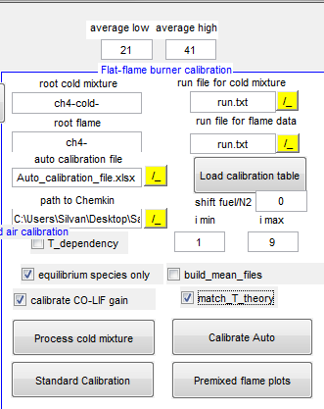

For Hencken:

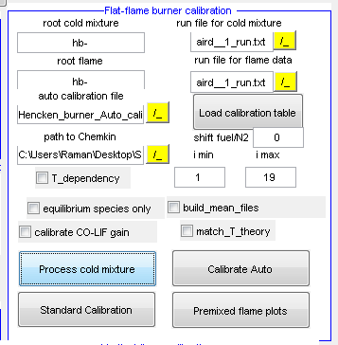

How it works:

|  |  |  |  |  |  |  |  |
| --- | --- | --- | --- | --- | --- | --- | --- |
| Main | Crosstalk 1 | Crosstalk 2 | TolFun | TolX | MaxIter | Istart | iend |
| CO2 | CO2 | CO2 | 1,00E-06 | 1,00E-02 | 31 | 1 | 5 |
| species talked onto | Species talking onto | Don’t use, special feature | Parameter for optimization | Parameter for optimization | # of max iterations | Ch4-X flame to start with | Ch4-X flame to end |

1. reads Auto_calibration_file.xlsx, sheet 1  
   e.g.:
2. executes step by step the response talks / crosstalks to be modified-> for these steps create a new Auto_calibration_file.xlsx, make entries in rows and load it
3. based on the ch4-x to ch4-y files stated matlab does a minimum difference optimization
4. plots results with old and new response talk factors (x talk factors respectively)

* average low / average high: states pixel ranges to use for function
* root cold mixture: ch4-cold- (for hencken: hb- since there are no cold files)
* root flame ch4- (for hencken: hb-)
* path to Chemkin: state path where ff calculations are stored: methane_flame_theory.xlsx
  + for hencken: Hencken_theory.xlsx
* T_dependency: work in progress- don’t use it (uncheck)
  + i min / i max: range of ch4-x flames to take
* run_file for cold mixture: aird_run.txt
* run_file for flame: aird_run.txt (only different one if you don’t want to use the same one -what is rarely done)
* [Load calibration table]: hit this in case not running with original runfile – hardly ever used
* Shift fuel / N2: used for Hencken flame where phi is not determinedd from cold gases – in case MFC where miscalibrated – to pick right phi
* Equilibrium species: default checked: kills equilibrium species (e.g. CH4, O2 in rich flames)
* Build mean files: default checked (when running the first time): process mean of 100 files ( need to be build only once; saved as ch4_mean, where 9 images are in one set, each shot stands for mean of one ch4-x)
  + Uncheck later for tweaking parameters – speeding up
* Calibrate CO-LIF gain: (arguable) LIF gain is fixed/updated to theoretical value that CO-LIF fits theoretical value
* Match_T_theoretical: default checked: fixes temperature to equilibrium calculations

Hit:

Hit [Process cold mixture]: process cold then flame results -> get ch4/N2 ratio in cold

Hit [Standard Calibration]: does the optimization of the parameters stated in Auto_calibration_file.xlsx

* Check the resulting plots: species that fit the calculations can be stopped in optimization
* Since multiple dependencies are ther it makes sence to do e.g. CO2, O2<<CO2, CO2, O2<<CO2 sequentially in one Auto_calibration_file.xlsx
* Use this function carefully; check if found paramters are not to far off of 1; if so there must be some other issue (e.g. shift, bowing, normalization,… wrong) –

[Calibrate Auto]: not recommended to use ( for T_dependecy plots); to use: check the species to tweak on the right side:

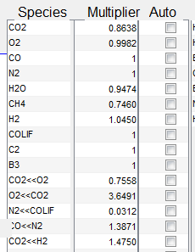

* Takes i_min / i_max flames to perform calibration

[Premixed flame plots]: not used; processes all 100 shots and plots radial profiles

Vertical flame calibration

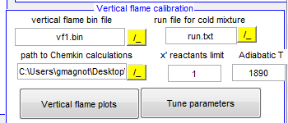

Work in progress; don’t use

* Used to determine shift of cameras against each other
  + Minimize crosscorrelation of T_pg and T_ray
  + Output is printed in Raman_GUI: - Camera Parameters -, center shift
    - For CO camera done manually
    - So far do it manually (T_pg and T_ray) and enter it in Raman_GUI: - Camera Parameters -, center shift

Run batch mode

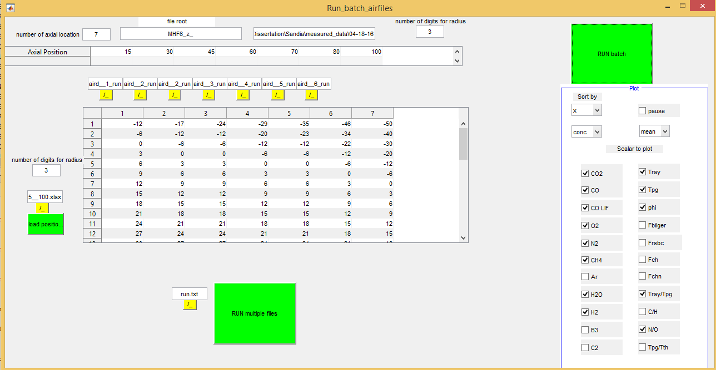

* Axial positons: hard coded in Run_Batch_airfiles
* Select runfiles for every axial position
* Load radial position .xlsx #

Hit [RUN batch]